**A REPORT**

**ON**

**ANALOG ASSIGNMENT**

Submitted in partial fulfillment of the course

**Analog & Digital VLSI Design**

BY

**Likhit Teja Valavala 2015A3PS0221P**

**Santosh Das 2015A3PS0281P**

**Shikhar Shiromani 2015A3PS0194P**

**Mayank Raj 2015A8PS0488P**

Under the supervision of

**Dr. Anu Gupta**

*Professor, Department of Electrical & Electronics*

**Dr. Nitin Chaturvedi**

*Assistant Professor, Department of Electrical & Electronics*

AT



**BIRLA INSTITUTE OF TECHNOLOGY & SCIENCE, PILANI**

**Ques 40.**

**Design a two stage single-ended output OPAMP(differential +gain stage) for the following specification**

**a) Analysis of all equations of your design, with a systematic derivation of all transistors W/L ratios and spectre simulation of circuit for the following specifications.**

**i) DC gain ≥ 80 dB**

**ii) UGB ≥ 400MHz**

**iii) Output voltage swing ≥ 2V**

**iv) PSRR ≥ 120dB**

**v) Output offset voltage ≤ 40mV**

**b) Show a biasing circuitry to bias all the voltages in your design (except the input).**

**c) STB analysis to calculate the closed loop gain and phase margin for the OPAMP.**

**d) Calculate and plot the following parameters for your OPAMP: DC gain, Bode plot for AC gain and phase, CMRR plot, ICMR plot, PSRR plot, slew rate, settling time, Output voltage swing (dc + Transient), power consumption, and input and output offset voltage.**

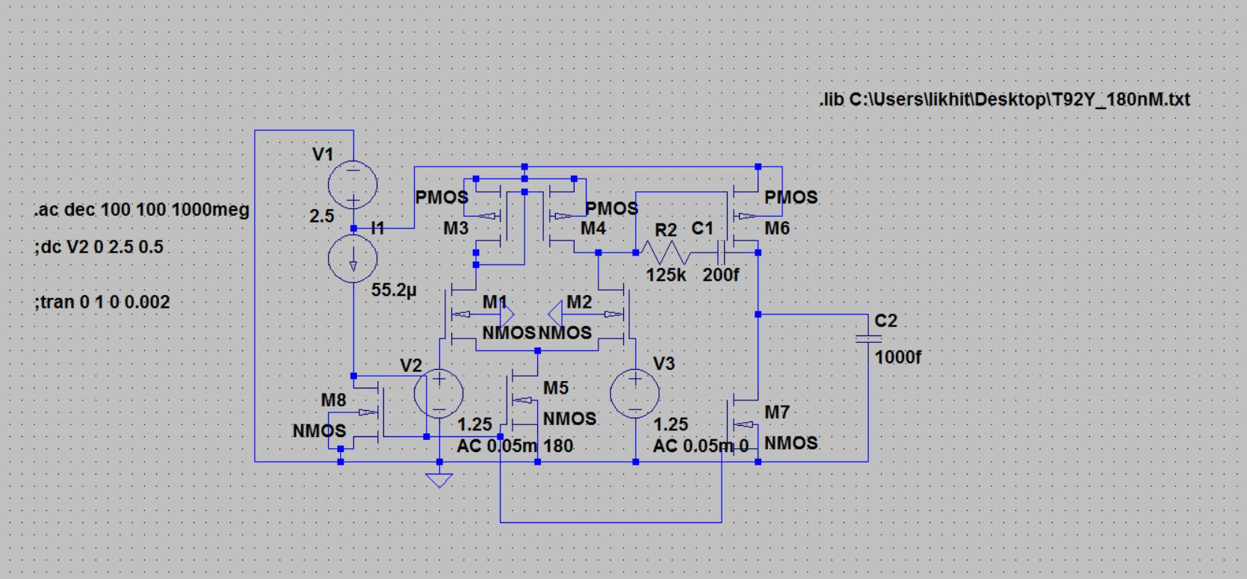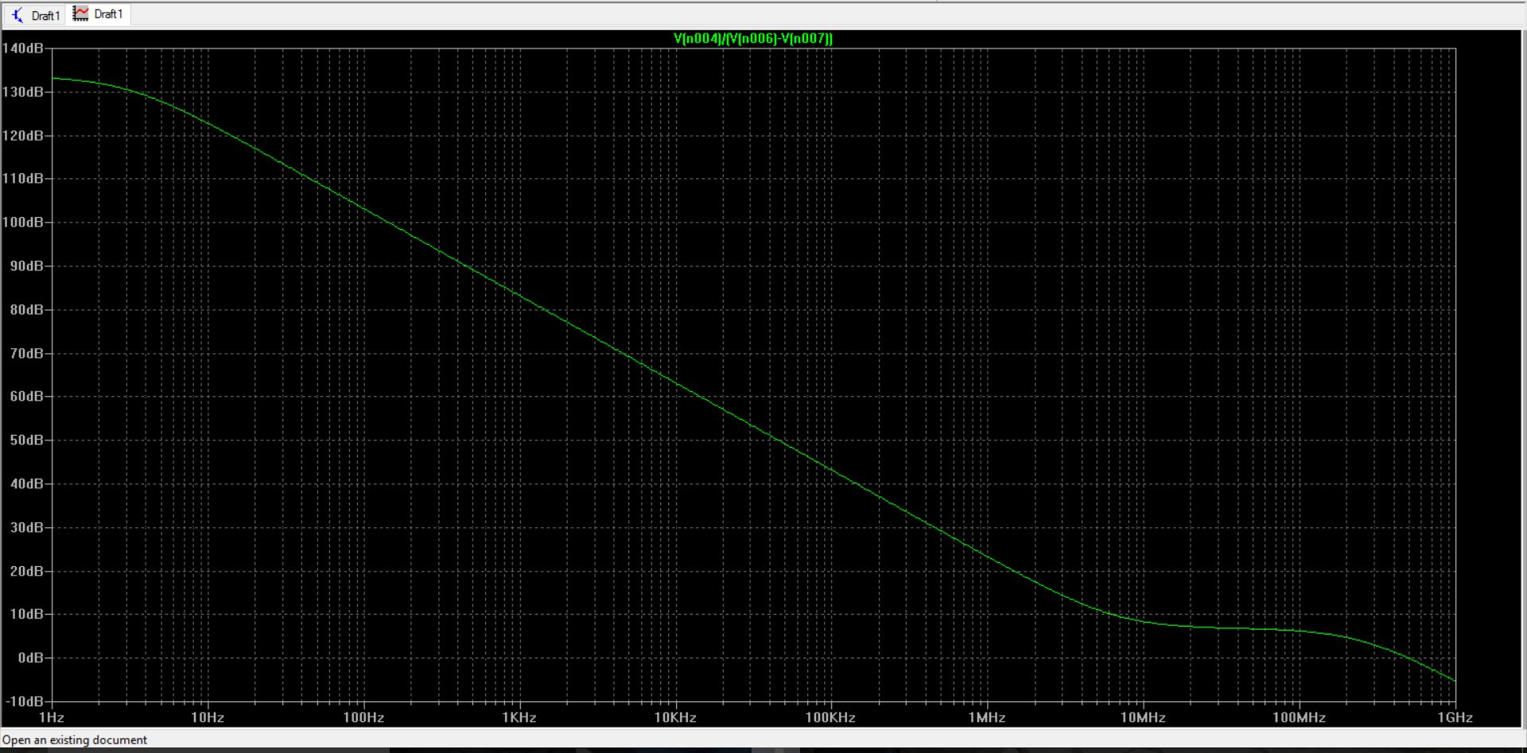

**Differential Mode Gain Schematic and Plot**

**Adm = 132 dB (approx.)**

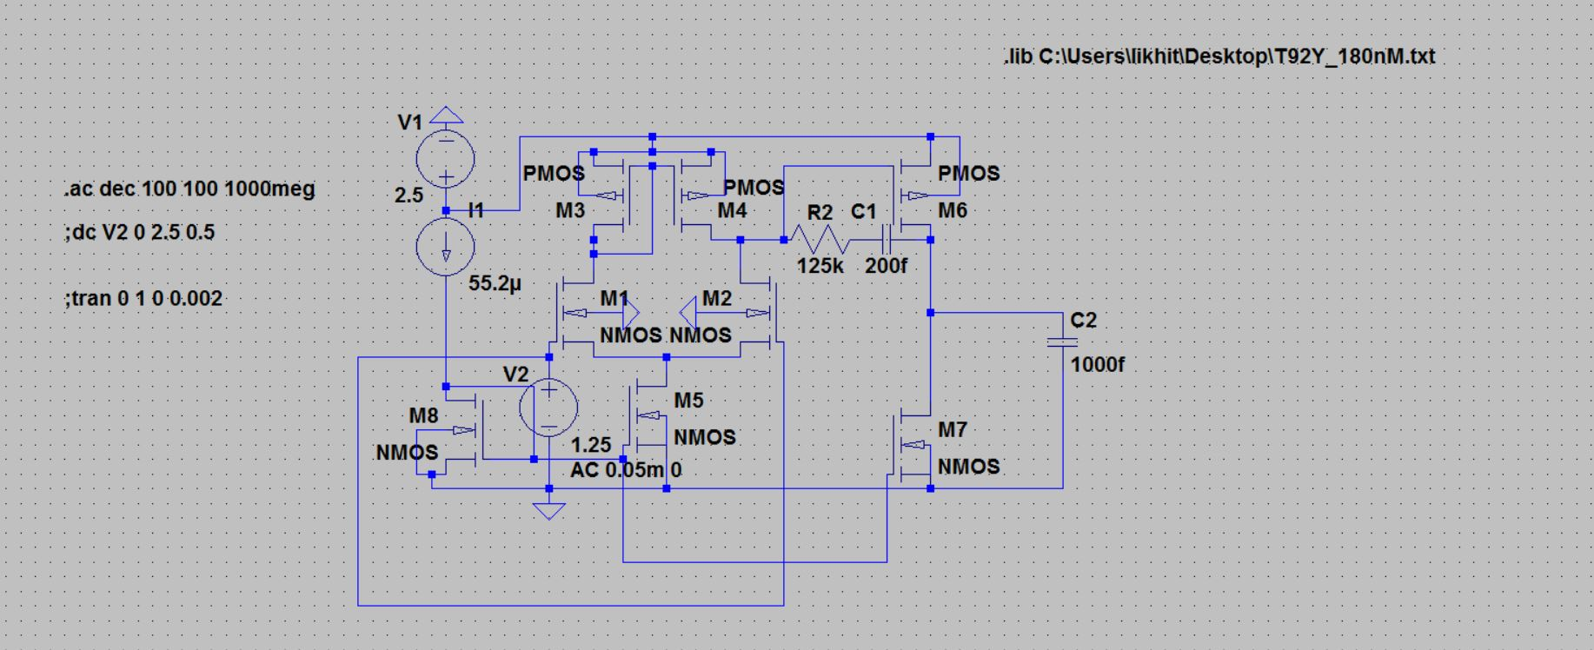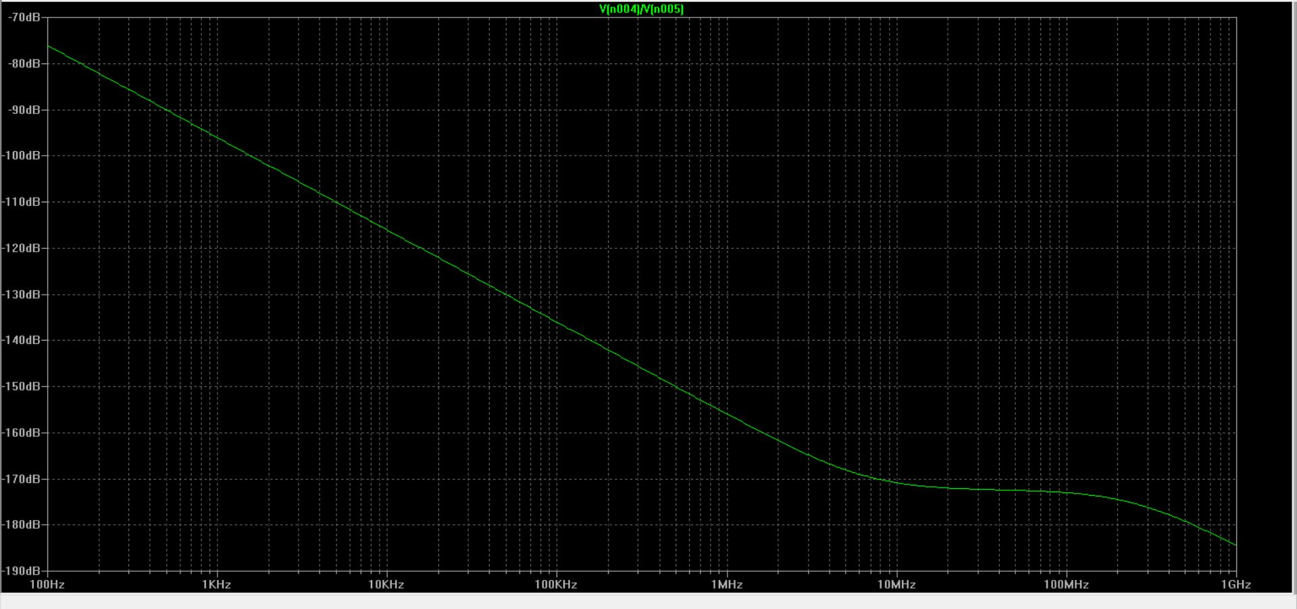

**Common Mode Gain Schematic and Plot**

**Acm = -78 dB ( approx.)**

**CMRR = Adm(dB) – Acm(dB) = 210 dB(approx.)**

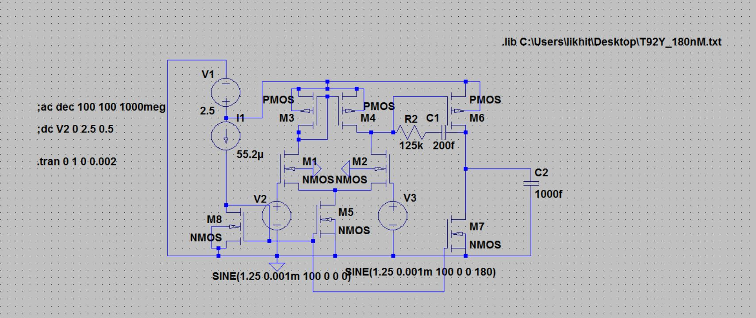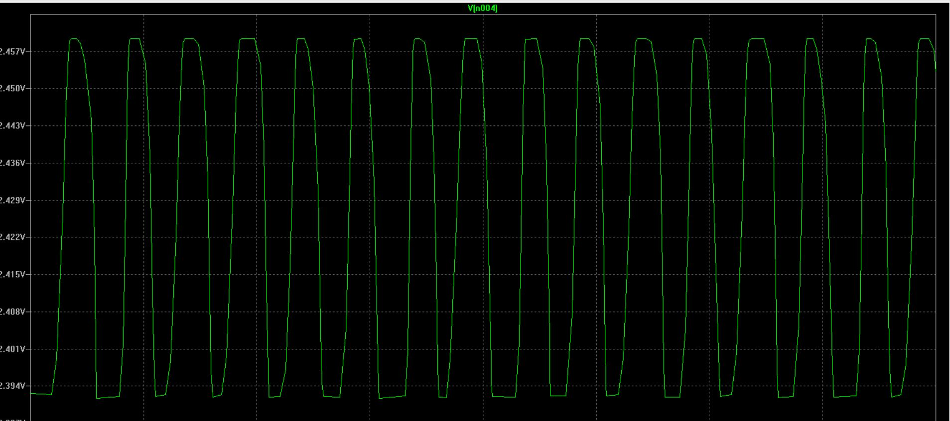

**DC Gain Schematic and Plot**

**DC Gain = 85 dB (approx.)**

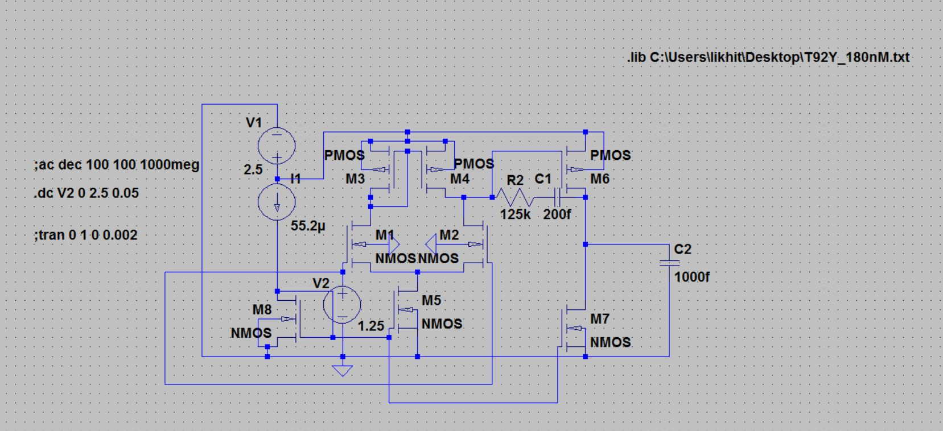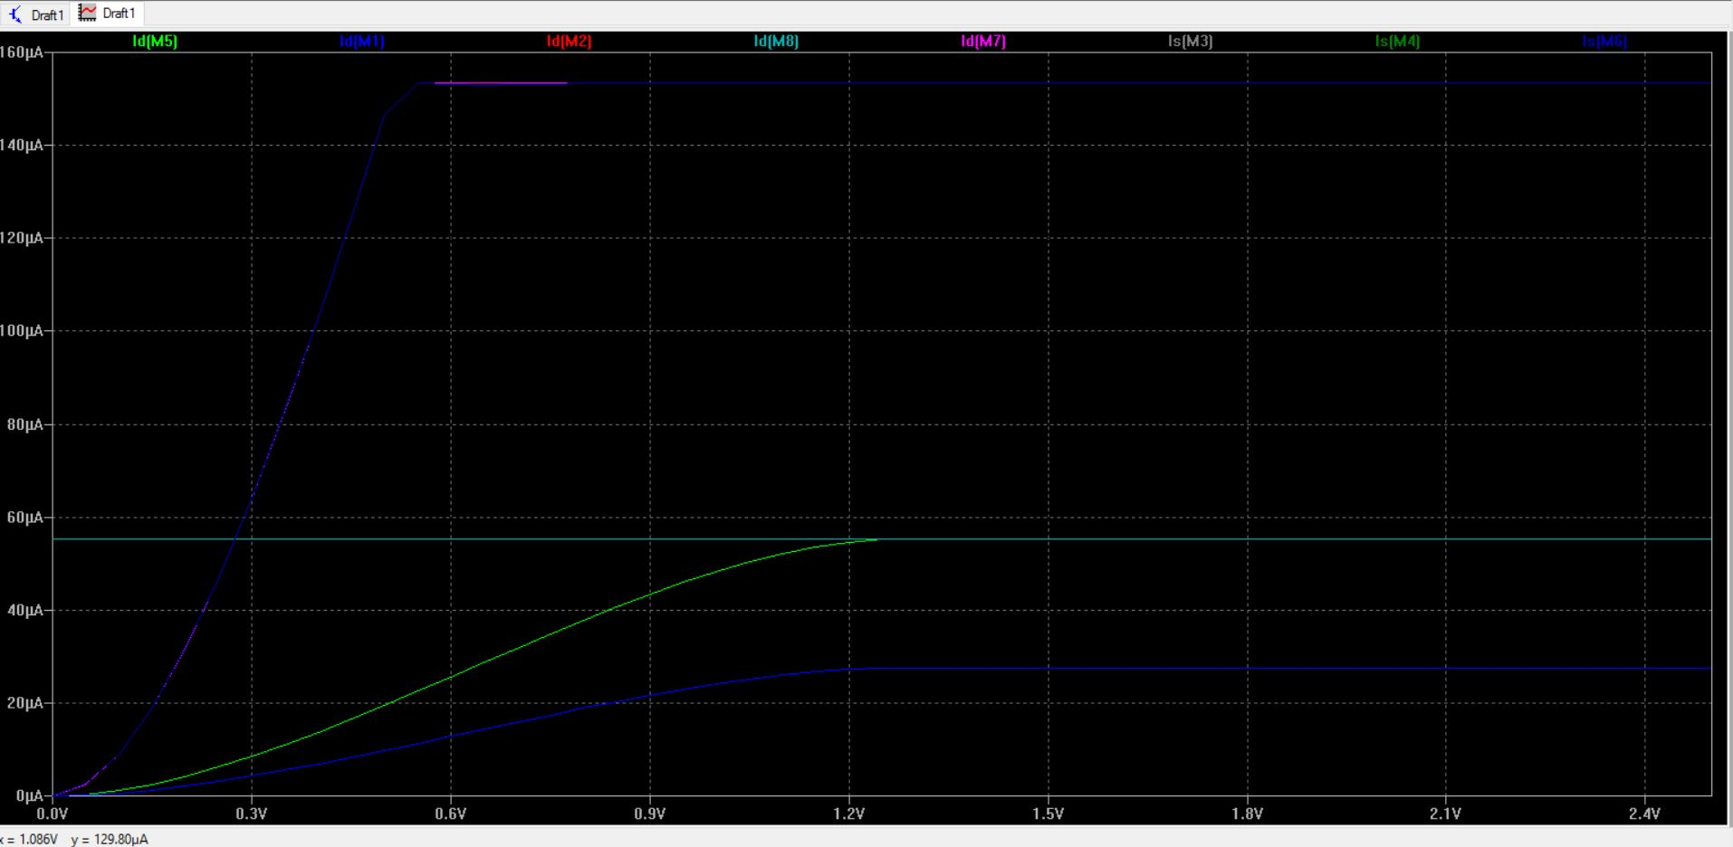

**ICMR Schematic and Plot**

**ICMR = 2.5 V – 1.2 V = 1.3V**

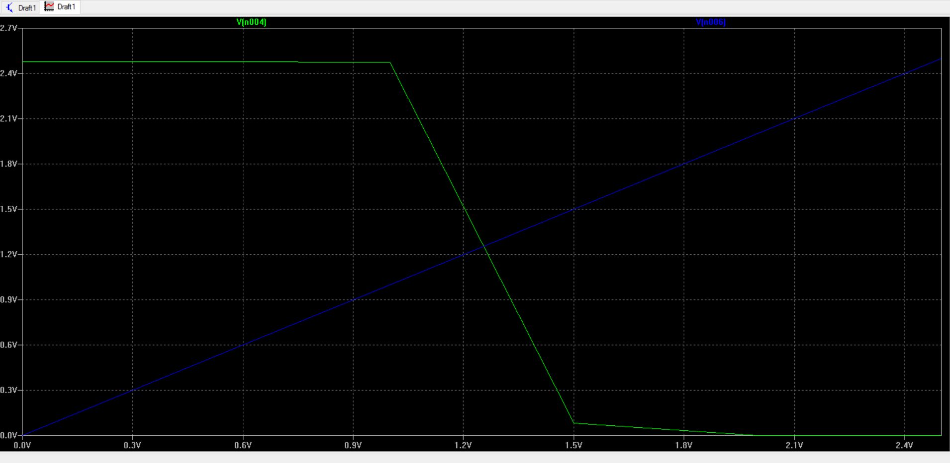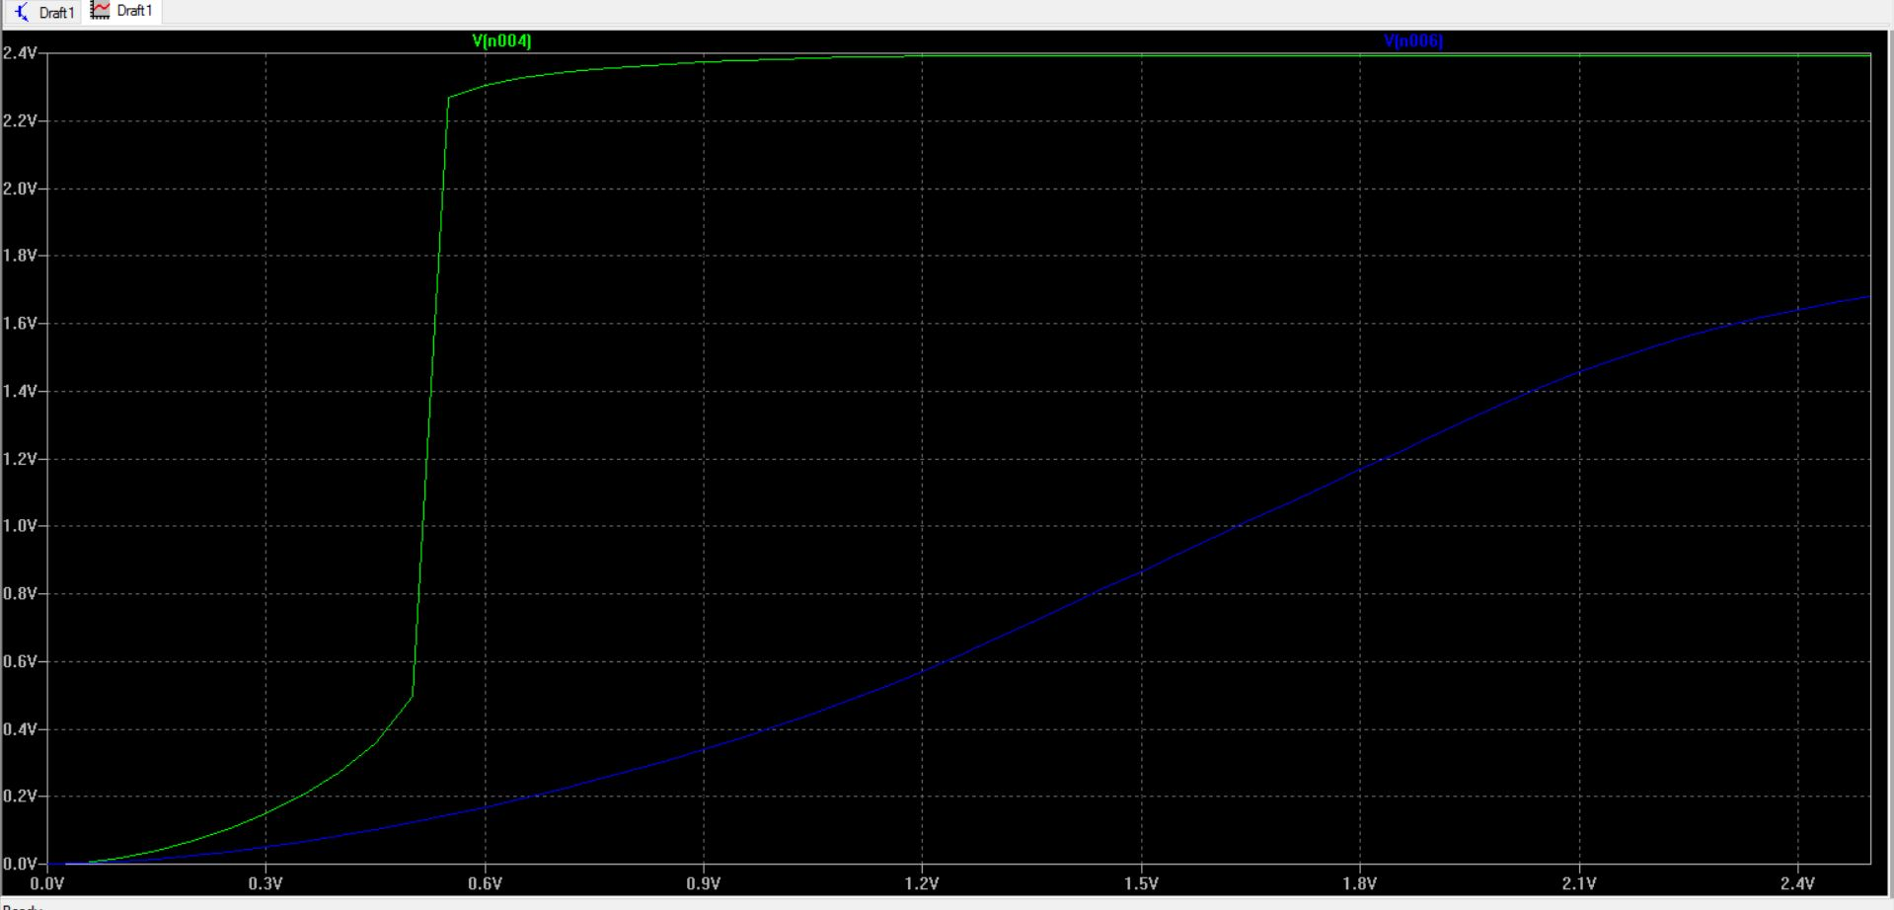

**Output Swing Plot**

**Output Swing = 2.4 V**

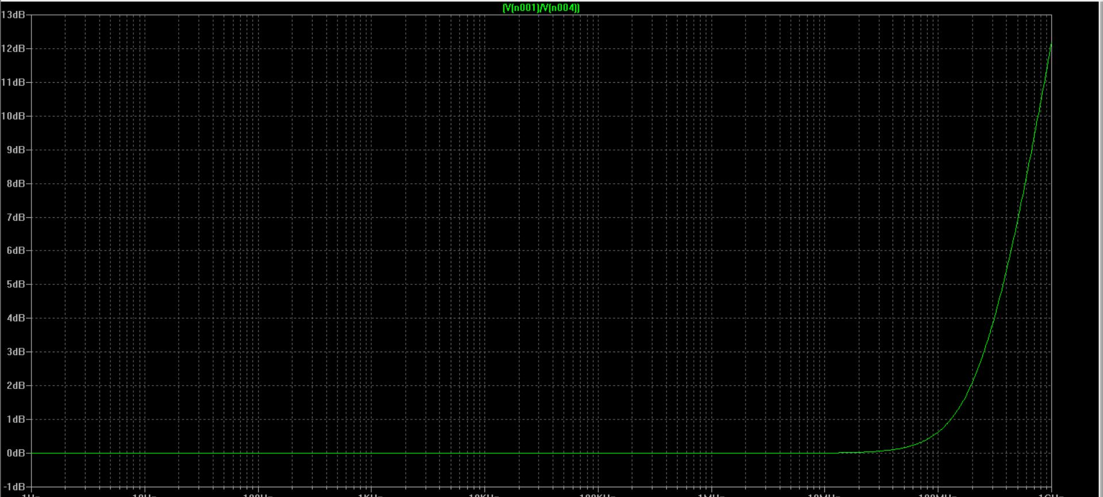

**PSRR Plot (change in Vdd/change in Vout)**

**PSRR [dB]=20*log((change in Vdd/change in Vout)*Gain)**

(Add the above graph with Adm graph for different frequencies)

**Hand Calculations :**

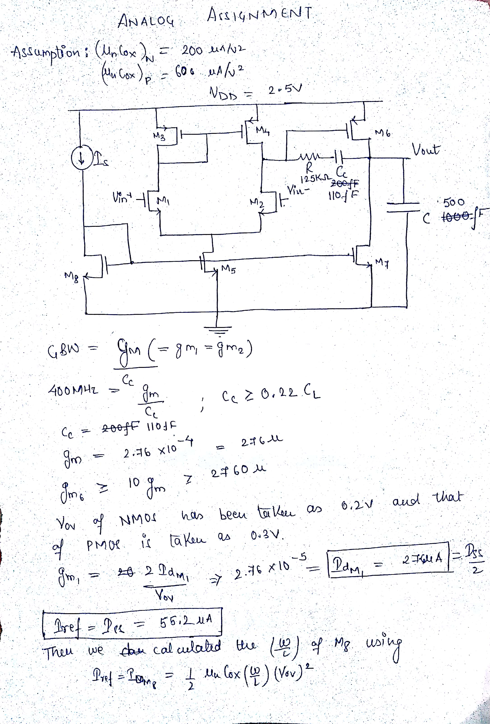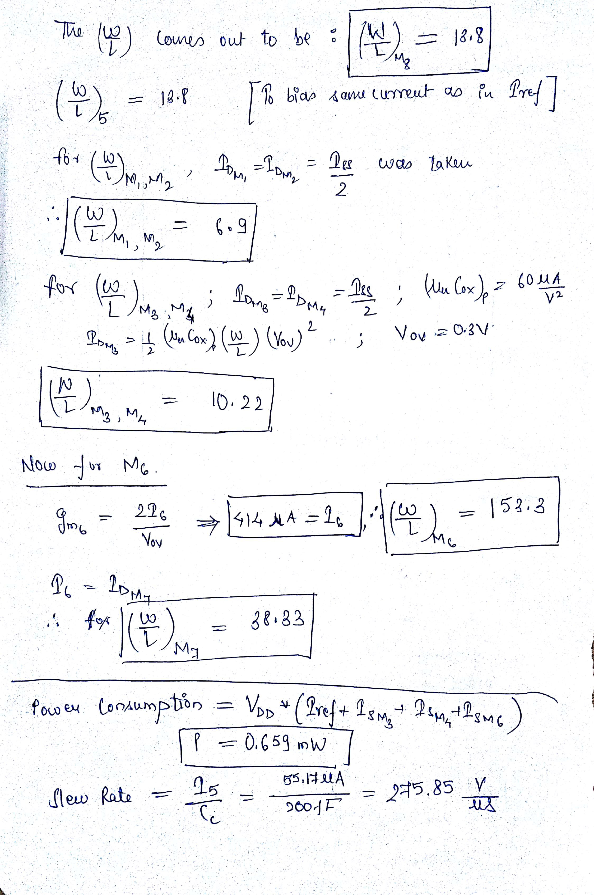

|  |  |
| --- | --- |
| MOSFETs | W/L ratios |
| M1 | 6.9 |
| M2 | 6.9 |
| M3 | 10.22 |
| M4 | 10.22 |
| M5 | 13.8 |
| M6 | 153.3 |
| M7 | 38.33 |
| M8 | 13.8 |

Table 1: W/L values for all MOSFETs

|  |  |  |  |
| --- | --- | --- | --- |
| SL No. | Quantity | Value | Required specs |
| 1. | DC gain | 85 dB | >=80 dB |
| 2. | Output Swing | 2.4 V | >=2 V |
| 3. | ICMR | 1.2 V – 2.5 V | - |
| 4. | Slew Rate | 275.85 V/µs | - |
| 5. | Power dissipation | 0.659 mW | <=3mW |
| 6. | Input Offset Voltage | 0 V |  |
| 7. | Output Offset Voltage | 0 V |  |
| 8. | PSRR | 130 dB | >=120 dB |
| 9. | UGB | 500 Mhz | >=400Mhz |

Table 2: Calculated and required specs